**Standing Waves and Harmonics**

1. A hammer hits the end of a bar that is 1.2 m long. Sketch the standing wave on the bar for the first four harmonics. The speed of waves in the bar is 6500 m/s. (Assume that the harmonic series of vibrations on a bar are like the displacement patterns in an open tube.)

|  |  |  |  |
| --- | --- | --- | --- |
| **Mode** | **Diagram** | **Wavelength** | **Frequency** |
|  |  |  |  |
|  |  |  |  |
|  |  |  |  |
|  |  |  |  |

1. Sketch the standing wave patterns for sound in a resonating pipe that has a fixed boundary on one end and a free boundary on the other. The length of the object is 90.0 cm.

|  |  |  |  |
| --- | --- | --- | --- |
| **Mode** | **Diagram** | **Wavelength** | **Frequency** |
|  |  |  |  |
|  |  |  |  |
|  |  |  |  |
|  |  |  |  |

1. Describe the type of pipe that would have the standing waves described in each situation below.
   1. The wave has displacement antinodes at both ends of the tube
   2. The wave has a displacement antinode at one end of the tube and a node at the other end of the tube.
   3. The wave has displacement nodes at both ends of the tube.
2. A uniform narrow tube 1.8 m long is open at both ends. It resonates at two successive harmonics of frequency 275 Hz and 330 Hz. What is the speed of sound in the gas in the tube?
3. A violin string is 0.65 m in length.
   1. Sketch the standing waves produced for the 1st and 2nd harmonics and determine their wavelengths.

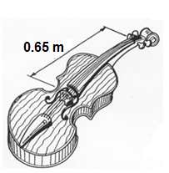

**1st Sketch Wavelength = ________**

**2nd Sketch Wavelength = ________**

* 1. If the wave speed in the string is 4.00 × 102 m s-1, calculate the frequencies of the first two harmonics.

1. 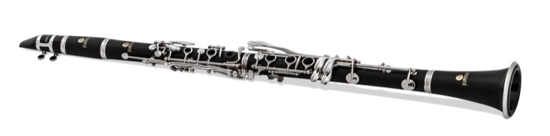The clarinet, pictured at right, is a wind instrument that behaves like a closed pipe with a fundamental frequency of 130 Hz in air at a room temperature of 25 ºC.
   1. What are the frequencies of the next two higher harmonics?
   2. Sketch the particle displacement vs distance envelopes for the fundamental frequency and for the next harmonic frequency above the fundamental for this instrument.

fundamental frequency

next harmonic frequency

* 1. Calculate the length of the clarinet.

The clarinet is played so as to produce its fundamental frequency, and the sound is captured by a microphone and feed into an amplifier. Two loudspeakers X and Y are connected in phase to the amplifier and set up facing each other a distance of 8.5 m apart. A person walking from one of the loudspeakers towards the other hears points where the sound is extremely soft, alternating with points where it is loud.

X

Y

Amplifier

8.5 m

* 1. Why will the person hear a series of soft and loud points as they walk from one loudspeaker towards the other?
  2. Calculate whether the sound is loud or soft when the person walking between the loudspeakers is 2.92 m from speaker X.
  3. What is the distance between a soft and a loud point?
  4. Determine the number of soft points between the loudspeakers.

1. 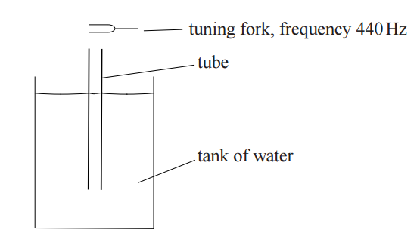An experiment is being carried out to estimate the speed of sound. The equipment used is shown below.

A hollow tube is placed vertically in a tank of water, until the top of the tube is just at the surface of the water. A tuning fork of frequency 440Hz is sounded above the tube. The tube is slowly raised out of the water until the loudness of the sound reaches a maximum for the first time, due to the formation of a standing wave.

* 1. Explain how the standing wave is formed in the tube.

It is found that when the tube is raised an extra 37 cm, the sound at the opening reaches a maximum for the second time.

* 1. Label with an “X” the point in the tube which is always a displacement node.
  2. Using the information provided, estimate the speed of sound. Show all working.

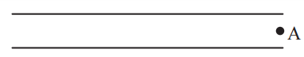A standing wave is established in a tube **open at both ends**. Point A shows the position of an air particle at one of the open ends.

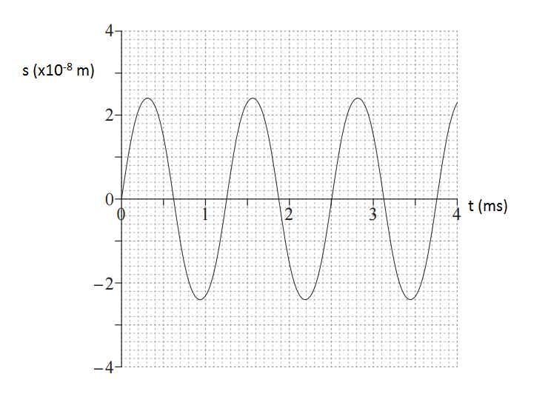The graph below shows how the position of point A varies with time.

* 1. Is point A a displacement node or antinode? Explain your choice **by referring to the graph**.
  2. What is the frequency and wavelength of the standing wave when the speed of sound is 346 ms-1?
  3. The standing wave formed in the tube corresponds to the fourth harmonic for the tube. Find the length of the tube.

1. Panpipes, or pan flutes, can be traced back to Greek, Mayan, Native American, and many other ancient cultures. Although the sizes and styles differ across cultures, the basic design is a series of closed-end tubes of varying length, fixed together. The sound is produced by blowing into the pipes and setting the column of air inside into motion. Once the wave pattern is stabilized it is known as a standing wave.
   1. Will the closed end of the tube always serve as a displacement node or an antinode? Briefly explain your answer in terms of interference of waves.
   2. Determine the relationship between the wavelength of the **fundamental** frequency and the length of the tube.
   3. If a pipe of length 30.4 cm was made to resonate at its fundamental frequency, calculate the frequency of sound produced. (2 marks)
   4. The tube is now vibrating with a standing wave pattern of three antinodes and three nodes. State which overtone this represents. Draw a particle displacement diagram below to aid your answer. (2 marks)

Overtone: ____________

* 1. A student wishes to make another pipe that produces sounds 1 octave above this (i.e. twice its frequency). Calculate the length pipe she will need to make. Justify your answer.(2 marks)
  2. An internet guide to making your own panpipe suggests that each pipe is 9/8 the length of the previous. One of the pipes resonates at its 3rd harmonic, producing an A note of 440 Hz.
  3. Calculate the frequency of the fundamental note produced by the 3rd longest pipe after the one producing the A note. (4 marks)

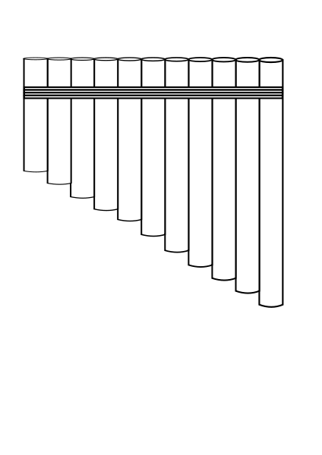

Frequency

A Note